Install AZURE CLI Plugin and configure following Global Env Variables in Jenkins:

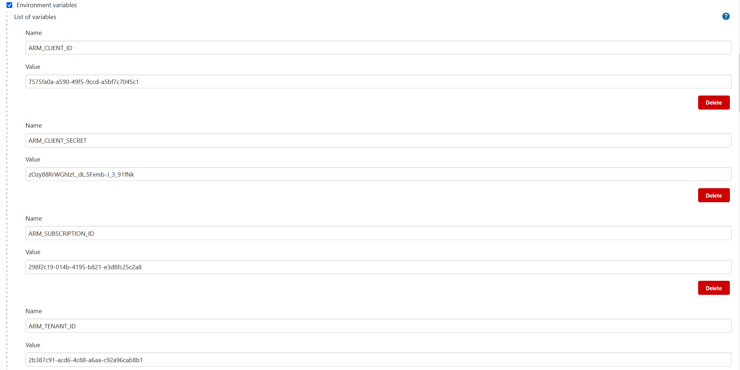

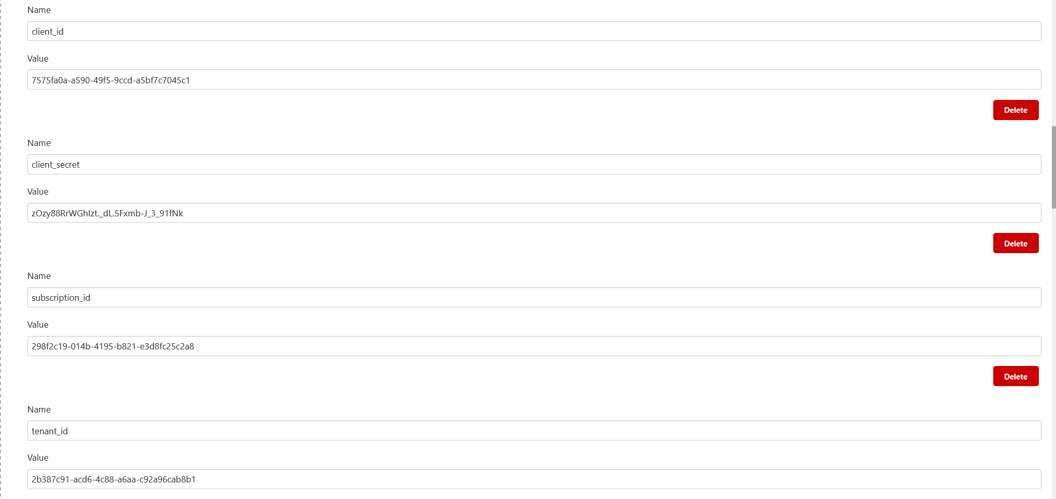

Create a pipeline job and provide the following pipeline.

/\*Jenkins File For Declarative Syntax for CI/CD of Git Packer Terraform \*/

pipeline {

agent any

stages {

stage('Clone Git Repo') {

steps {

git branch: 'master',

credentialsId: 'GitHubCreds',

url: 'git@github.com:SreeVeerDevOps/LIC-IaaC.git'

}

}

stage('Listing Files In Repo') {

steps {

sh "pwd"

sh "ls -al"

}

}

stage('Checking Azure Credentials') {

steps {

azureCLI commands: [[exportVariablesString: '', script: 'az group list']], principalCredentialId: '11376a91-9a2a-481f-8070-7890fb9a1e09'

}

}

stage('Checking Terraform Version') {

steps {

sh "terraform version"

}

}

stage('Terraform Init & Validate') {

steps {

sh "terraform init"

sh "terraform validate"

}

}

stage('Terraform Plan') {

steps {

sh "terraform plan"

}

}

stage('Terraform Apply') {

steps {

sh "terraform apply --auto-approve"

}

}

stage('Terraform Destroy') {

when {

// Only say hello if a "greeting" is requested

expression { params.DESTROY == 'YES' }

}

steps {

sh "terraform destroy --auto-approve"

}

}

}

}